Does more grant funding translate to higher productivity?
An examination of NIH grant funding and resulting publications and patents

by
Xiang Yu

Proposed Capstone Project for The Data Incubator Semifinalist Program, Spring 2018

Introduction

Each year, the National Institutes of Health (NIH) award more than 80 percent of their $37.3 billion budget as competitive grants to thousands of researchers in every state of the country and around the world (1). This nearly $40 billion investment in basic science and medical research is a major driving force for the greater research community.

Typically, NIH grants are provided as an annual award through a 3-5-year cycle, after which the grants are reapplied and reevaluated for next cycle of funding opportunity (2). Because of the substantial size and competitive nature of the grants, it is of interest to objectively evaluate the impact of these grants and help inform the future dissemination of the funding. For example, should the agencies award fewer grants at higher funding, or the opposite, award more grants at lower dollar amounts?

Some of the commonly used metrics are the number and quality of peer-reviewed publications and the number of patents resulting from each grant. This research project sets out to investigate this approach and evaluate whether the amount of grant awarded correlates with either the number and quality of publications produced or the number of patents issued. Additionally, we look at other characteristics of the grant structure that may impact the outcome of the research.
Research Questions
- What can we learn from the number of publications associated with NIH funded research grants?
- What are the characteristics of grants with publication success (i.e. type of grant, the area of focus, type of institution)?

- Does more funding lead to a higher quality of publication?

- Does more grant money lead to a greater number of patents issued?
Data Description
NIH monitors the life cycle of all of its grants by collecting data on (1) funded projects, (2) abstracts, (3) publications, (4) patents, and (5) clinical studies associated with each award. NIH releases weekly and annual updates through its Reseach Portfolio Online Reporting Tools (RePORT) website, where publicly downloadable files are available (https://exporter.nih.gov/default.aspx).

A typical grant runs on a 5-year cycle, so each grant in progress is followed over the time period 2012 to 2016 and examine levels of annual funding, the number and quality of publications, and the number of patent applications. The characteristics of peer-reviewed publications and patents resulting from these grants over the same period will are analyzed.

Each grant has an unique identifer. The identifier allows linking the data on basic project details (amount, project start and end, grant type, recipient institution, etc.) to the outcomes NIH uses to measure the performance of the grant, such as detail on publications and patents.

In addition to the unique identifier, the data on publications provide information on publication date/issue, journal title, authors, and language. The patent data has a patent ID and title, in addition to the unique identifier that links the patent information to the grant award.

Finally, data on journal quality are scraped from CiteFactor.org to supplement grant performance evaluation. These sources provide a quantitative indicator, the impact factor, as a measure of journal quality. The impact factor is derived from the frequencies with which an average article in a journal is cited in a particular year. This factor would be used in combination with the quantity of publication to provide a more in-depth evaluation.

Table 1. Data Sources and Documentation
Data Source | URL
NIH RePORT Sources
NIH Funded Projects | https://exporter.nih.gov/ExPORTER_Catalog.aspx?sid=2&index=0
Publications from funded projects | https://exporter.nih.gov/ExPORTER_Catalog.aspx?sid=0&index=2
Projects-Publications-Patents Link Table | https://exporter.nih.gov/ExPORTER_Catalog.aspx?sid=2&index=5
Patents Issued | https://exporter.nih.gov/ExPORTER_Catalog.aspx?sid=1&index=3
RePORT Data Dictionaries | https://exporter.nih.gov/about.aspx
Journal Quality
CiteFactor | http://www.citefactor.org/journal-impact-factor-list-2015.html
Researchgate.net | https://www.researchgate.net/post/How_can_I_find_the_list_of_Impact_Factor_20152

Exploratory analysis
A total of 85,013 grants awarded between 2012 and 2016 with at least 1 publication between
2012 and 2017 were analyzed. The median funding is $729875/year, and median publication number is 6.

Intramural vs Extramural Grants
Intramural funding is provided to agencies located at or associated with NIH, while extramural grants are largely awarded to researchers at academic institutes. There has been a simmering debate over the funding level of intramural research compared to extramural. Some extramural researchers consider intramural funding “generous” while a number of experts regard some intramural research “overly conservative” and “short-sighted”(4,5,6). Extramural grants are further divided into research projects, contracts, cooperative work with NIH staff. This study will compare the outcomes of interest – publication numbers and quality and successful patent applications – for intramural and extramural grants.

The median funding over the 5 years for intramural researcher grants (n=3,114) is $2,523,000, versus $707,771 for extramural research (n=81,867). Also based on the 5-year data on publications, the distributions of cost (to NIH) per publication for intramural research (top) and extramural research (bottom) are shown in the histograms in Figure 1.

Figure 1 suggests that intramural research tends to have a higher cost per publication compared to extramural research: median cost at $305,492 versus $115,611. Yet one has to keep in mind that the mission of NIH intramural research is to conduct “unique” and more “innovative” projects (5,6). Maybe the higher risk involved with these innovative projects would produce higher number of greater successes as well as failures, as evident by the slightly higher spread of extreme high and low cost per publication frequencies at both ends of the bell-shaped histogram.

Grant Type
There are dozens of different types of grants awarded by NIH – that range from basic science research to infrastructure spending to support research facilities. Some type of grants is associated with an extremely high number of publications. For example, certain grants are awarded to support shared resources and facilities (2). These facilities typically provide a highly demanded technical service at research centers. Naturally, these type of grants would be associated with more publications since they provide a specific service for all other researchers. Therefore, it would not be fair or productive to compare grants that awarded to a facility vs grants awarded to individual researchers.

For preliminary study, we select 3 types of common grants: a “large” grant typically issued awarded to individual researchers at established institutions (R01), a “medium-sized” grant typically issued for exploratory studies (R21), and a “small” grant given to junior researchers who are on the path to apply for their first R01 grants (K99).

As shown in Figure 2, the cost per publication across these 3 types of grants, the small K99 grants seem to produce more “bang for the buck”. Maybe the extra motivation among junior researchers to gain a path to the larger R01 grants would gear the research towards higher efficiency, or maybe they are less willing to engage in risky projects that may not bear fruit.

Subject Focus
Are some fields in medical science more productive than others? Grants targeted for 3 of the major chronic diseases in the United States: cancer, heart disease, and diabetes were selected and their cost per publication was calculated. It appears that the diabetic research projects tend to have a higher cost per publication compared to projects in cancer and cardiovascular fields, as shown in Figure 3.

Conclusion
The mechanism of NIH grant application and dissemination is a highly complex. Among the 85013 grants analyzed in this study, there are 100 different type of grants, ranging from a few thousand to hundreds of millions of dollars. This study only focused on the cost and number of publications from a 5-year period. Expanding the time frame, and also, following projects that had multiple renewals on a time-series model may provide a deeper insight. In addition to publication number, another metric could be examined is taking the impact factor of journals of these publications as a composite indicator, as some might argue, “quality over quantity”. Finally, one other factor could be used is the “citation per dollar” approach, as NIH have started to explore on their own (3).

References:

  - https://www.nih.gov/about-nih/what-we-do/budget

- https://grants.nih.gov/grants/funding/funding_program.htm

- https://nexus.od.nih.gov/all/2016/04/28/citations-per-dollar/

- https://www.statnews.com/2018/01/03/nih-biomedical-research-funding/

- https://acd.od.nih.gov/documents/reports/ACD-IRP-WG-report.pdf

- https://nexus.od.nih.gov/all/2012/05/18/piloting-the-1-5m-special-review/

Tables and Figures

Figure 1. Distribution of Cost (to NIH) per Publication
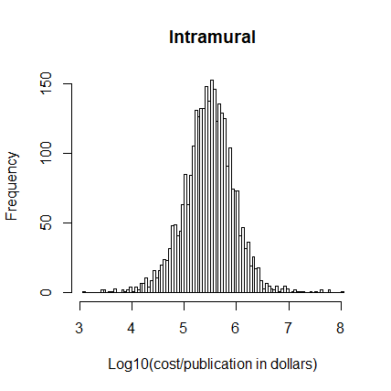
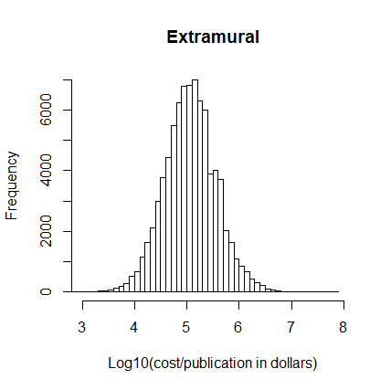
Figure 2. Dollar cost per publication of R01(large/established), R21(medium/exploratory studies), K99 (small/junior investigators) grants

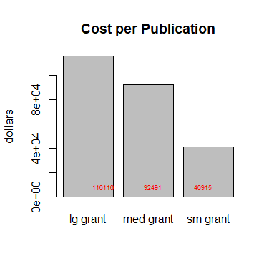

Figure 3. Dollar cost per publication by Grant Focus Type

